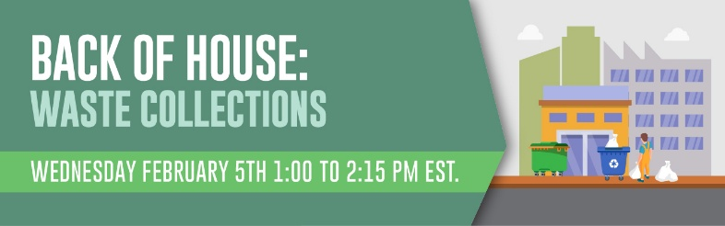
Webinar Chat Log

13:08:19 From Alec C: Here’s a link to download the Zero Waste Design Guidelines Clare referenced. https://www.zerowastedesign.org/
13:11:43 From Alec C: Type questions for Clare into the "Q&A" on your dashboard.
13:31:07 From James B: Clare's guidelines and process are proactive and preventive, but our experience is that often architects and building owners do not design for waste management and bring in equipment providers and consultants to shoehorn in compactors, bins, and balers.
13:32:56 From Clare M: Agree James, and we often work with buildings that haven’t been designed right - the same principles apply, you just need to consider the existing space requirements and constraints, but the system can always be improved and made better for staff.
13:33:02 From James B: I was gratified to hear Clare mention systems thinking.
13:40:17 From Rob M: Ref James Bernard's in his experience, "..often architects and building owners do not design for waste management..." Historically often security concerns were neglected in building design too. My point being that it's easier to incorporate the more attractive factors in design, an important lesson I think. Not meant as a knock on designers.
13:45:13 From Alec C: James observation points to the importance of advocating for a role reviewing plans for new buildings during the design process, as Courtney mentions in the Q&A. It's much easier to flag problems up front than try to adapt to bad design after the fact.
13:51:11 From James B: Upfront design is the way to go. In one case. we discovered that architectural software only projected FEL truck turning radius, not roll off serving trucks. In another case, the compactor ordered for the waste management space was a model's operation that exceeded the height of the space requiring structural modification to allow service to take place.

13:52:25 From Rob M: I have so much admiration for how much Ayodeji Oluwalana respects the Custodians, and seeks their input, whaat a great lesson!
13:55:17 From Jeremy K: I agree Rob!
13:56:51 From Jeremy K: Once this is over could you please send the recording to the participants. I would love to share this with others on my team.
13:57:09 From Courtney F: We held an open house/listening session for custodial supervisors on our campus
13:57:28 From Stephanie S: Seeking outside resources for support
13:57:49 From Clare M: I do too - we found that some of the best set up systems involved the creativity of custodians - in one housing development a custodian redesigned NYC’s food scrap bin, removing the raccoon proof latch and retrofitting with magnets - as these bins were indoors, it made it so much easier for the elderly residents to open.
13:59:49 From Amber K: At public school districts: Ask custodians one on one how the program is going, what challenges are they experiencing, what do we need to change? Valuing their input, and giving them your email address and phone number to reach out whenever helps foster that feeling that we're all in this together.
13:59:58 From Jon W: We still have waste cans at all workstations (600+), I routinely ask my staff what issues they’re seeing. I will speak with employees individually and ask them to change some behaviors to minimize the waste pickup process for custodians. They appreciate being heard and see positive change.
14:03:12 From James B: The presentations have edged into the issue of performance for zero waste certification. Even if you have connected the parts of the waste ecosystem together, all the efforts presented may not get to 90% diversion, the threshold for ZW certification. An answer is sorting teams as the ultimate downstream group. We (Great Forest) have designed, trained and implemented sorting programs for Large Refuse Generators (>40/week or presence of a compactor) in San Francisco and also for Facebook/Meta and Mastercard. Our clients consider the sorters to be essential to their success in increasing diversion and treat them well with recognition and praise.

14:03:14 From Clare M: Jon - we held a zero waste challenge with architects offices, and many of them removed workstation bins - temporarily one summer for the length of the challenge. While there was resistance, the fact it was temporary made it easier, and after the improved waste diversion and recognition, many kept that change.
14:07:04 From James B: The sorting teams we work with include a developmentally-disabled crew, an all-woman team, custodial service-based union group, and the employees provided by a "zero-waste facilitator" specialty firm.
14:09:22 From Amber K: Are any of those listening today from elementary, middle, or high schools? Are you using free standing bins for waste sorting or built-in sorting stations? We're currently finding that free-standing bins that can be accessed from both sides are the best option for our cafeterias, but we have a few schools with built-in stations. Those stations are currently fully non-operational.
14:10:51 From Emily C: Thank you! Unfortunately, I missed a large portion of this webinar. Will we have access to it?
14:12:40 From Becky B: @Amber-yes, freestanding, individual bins work best in a school setting for a variety of reasons. They are more flexible, easier to vary bin size, students can see inside the bins to help them determine what goes where, they are less expensive, etc.
14:16:01 From Mackenzie B: Hi Emily! Yes a recording of the webinar and the presentation slides will be sent over in an email within a day or two.
14:17:16 From Emily C: Thank you!
14:18:15 From Aline R: Will a recording of this webinar be provided?
14:18:38 From Mackenzie B: Hi Aline! Yes a recording of the webinar and the presentation slides will be sent over in an email within a day or two.
14:18:54 From Patty B: As for liners for recycling, keep in mind that if you use paper vs. plastic, most single stream recycling allows for paper bags to be included.
14:19:53 From Sharon R: Thank you
14:21:38 From Amber K: Thank you!

14:21:41 From Patty B: Great information by all the presenters! Thank you
14:22:09 From Aline R: Great - thanks, Mackenzie
14:22:09 From James B: Valuable presentations, Clare and Ayo!
14:22:23 From Clare M: thank you all - great audience and questions!
14:22:43 From Nira S: Great insights! Thank you to the hosts and panelists.
14:23:23 From Rob M: Great info. Thanks for putting this together!
14:23:47 From Courtney F: Thanks so much! Great presentations by all 3! Took lots of notes!
14:25:07 From Peggy C: Thank you all!
14:25:07 From Rebecca S: Thank you! Very informative
14:25:14 From Jeremy K: thank you
14:25:18 From David S: Thank you very much!

